UNITED STATES

SECURITIES AND EXCHANGE COMMISSION
Washington, D.C. 20549

FORM 8-K

CURRENT REPORT

Pursuant to Section 13 or 15(d)

of The Securities Exchange Act of 1934

Date of Report (Date of earliest event reported): February 8, 2023

GLOBUS MEDICAL, INC.

(Exact name of registrant as specified in its charter)

Delaware | 001-35621 | 04-3744954
(State or other jurisdiction | (Commission | (IRS Employer
of incorporation) | File Number) | Identification Number)

2560 GENERAL ARMISTEAD AVENUE, AUDUBON, PA 19403-5214

(Address of principal executive offices) (Zip Code)

(610) 930-1800

(Registrant’s telephone number, including area code)

Not Applicable

(Former name or former address, if changed since last report)

Check the appropriate box below if the Form 8-K filing is intended to simultaneously satisfy the filing obligation of the registrant under any of the following provisions (see General Instruction A.2. below):

- Written communications pursuant to Rule 425 under the Securities Act (17 CFR 230.425)

- Soliciting material pursuant to Rule 14a-12 under the Exchange Act (17 CFR 240.14a-12)

- Pre-commencement communications pursuant to Rule 14d-2(b) under the Exchange Act (17 CFR 240.14d-2(b))

- Pre-commencement communications pursuant to Rule 13e-4(c) under the Exchange Act (17 CFR 240.13e-4(c))

Securities registered pursuant to Section 12(b) of the Act:

Title of each class |  | Trading |  | Name of each exchange
 |  | Symbol |  | on which registered
Class A Common Stock, par value $.001 per share |  | GMED |  | New York Stock Exchange

Indicate by check mark whether the registrant is an emerging growth company as defined in Rule 405 of the Securities Act of 1933 (§230.405 of this chapter) or Rule 12b-2 of the Securities Exchange Act of 1934 (§240.12b-2 of this chapter).

Emerging growth company ☐

If an emerging growth company, indicate by check mark if the registrant has elected not to use the extended transition period for complying with any new or revised financial accounting standards provided pursuant to Section 13(a) of the Exchange Act. ☐

Item 2.02 Results of Operations and Financial Condition.

On February 9, 2023, Globus Medical, Inc. (“Globus Medical” or the “Company”) issued the Joint Press Release (as defined in Item 7.01 below) which contained certain preliminary financial results for the year ended December 31, 2022. A copy of the Joint Press Release is attached as Exhibit 99.2 to this Current Report and incorporated herein by reference.

The information contained in this Item 2.02 and the Exhibits hereto shall not be deemed “filed” for purposes of Section 18 of the Securities Exchange Act of 1934, as amended (the “Exchange Act”), or incorporated by reference in any filing under the Securities Act of 1933, as amended, or the Exchange Act, except as shall be expressly set forth by specific reference in such a filing.

Item 7.01 Regulation FD Disclosure.

On February 8, 2023, the Company entered into an Agreement and Plan of Merger (the “Merger Agreement”) with NuVasive, Inc., a Delaware corporation (“NuVasive”) and a direct wholly-owned subsidiary of the Company. On February 9, 2023, the Company and NuVasive issued a joint press release (the “Joint Press Release”) announcing their entry into the Merger Agreement. A copy of the Joint Press Release is attached as Exhibit 99.2 to this Current Report and incorporated herein by reference.

On February 9, 2023, representatives of the Company and NuVasive will present to investors an investor presentation (the “Investor Presentation”) in connection with the announcement of the Merger Agreement. The Investor Presentation provides information on both the Company and NuVasive, and an overview of the strategic rationale for the transaction. The Company may also present information contained in the Investor Presentation to analysts and investors from time to time. A copy of the Investor Presentation is available on the Investor Relations section of the Company’s website at www.globusmedical.com and is being furnished as Exhibit 99.1 hereto.

The information contained in this Item 7.01 and the Exhibits hereto shall not be deemed “filed” for purposes of Section 18 of the Exchange Act, or incorporated by reference in any filing under the Securities Act of 1933, as amended, or the Exchange Act, except as shall be expressly set forth by specific reference in such a filing.

No Offer or Solicitation

This current report is not intended to and does not constitute an offer to subscribe for, buy or sell, or the solicitation of an offer to subscribe for, buy or sell, or a solicitation of any vote or approval in any jurisdiction, nor shall there be any sale, issuance or transfer of securities in any jurisdiction in which such offer, sale or solicitation would be unlawful prior to registration or qualification under the securities laws of any such jurisdiction. No offer of securities shall be made except by means of a prospectus meeting the requirements of Section 10 of the Securities Act of 1933, as amended, and otherwise in accordance with applicable law.

Important Information About the Transaction and Where To Find It

In connection with the proposed transaction, Globus Medical will file with the U.S. Securities and Exchange Commission (“SEC”) a registration statement on Form S-4 that will include a joint proxy statement of Globus Medical and NuVasive and that will also constitute a prospectus of Globus Medical for shares of its class A common stock to be offered in the proposed transaction. Globus Medical and NuVasive may also file other documents with the SEC regarding the proposed transaction. This document is not a substitute for the joint proxy statement statement/prospectus or registration statement or any other document which Globus Medical or NuVasive may file with the SEC. INVESTORS AND SECURITY HOLDERS OF GLOBUS MEDICAL AND NUVASIVE ARE URGED TO READ THE REGISTRATION STATEMENT, WHICH WILL INCLUDE THE JOINT PROXY STATEMENT/PROSPECTUS, AND ANY OTHER RELEVANT DOCUMENTS THAT ARE FILED OR WILL BE FILED WITH THE SEC, AS WELL AS ANY AMENDMENTS OR SUPPLEMENTS TO THESE

DOCUMENTS, CAREFULLY AND IN THEIR ENTIRETY BECAUSE THEY CONTAIN OR WILL CONTAIN IMPORTANT INFORMATION ABOUT THE PROPOSED TRANSACTION AND RELATED MATTERS. The registration statement, definitive joint proxy statement/ prospectus and other documents filed by Globus Medical and NuVasive with the SEC will be available free of charge at the SEC’s website (www.sec.gov) and from Globus Medical and NuVasive. Requests for copies of the joint proxy statement/ prospectus and other documents filed by Globus Medical with the SEC may be made by contacting Keith Pfeil, Chief Financial Officer by phone at (610) 930-1800 or by email at kpfeil@globusmedical.com, and request for copies of the joint proxy statement/prospectus and other documents filed by NuVasive may be made by contacting Matt Harbaugh, Chief Financial Officer, by phone at (858) 210-2129 or by email at investorrelations@nuvasive.com.

Participants in the Solicitation

Globus Medical, NuVasive, their respective directors and certain of their executive officers and other employees may be deemed to be participants in the solicitation of proxies from Globus Medical’s and NuVasive’s shareholders in connection with the proposed transaction. Information about the directors and executive officers of Globus Medical and their ownership of Globus Medical stock is set forth in Globus Medical’s annual report on Form 10-K for the fiscal year ended December 31, 2021, which was filed with the SEC on February 17, 2022 and its proxy statement for its 2022 annual meeting of stockholders, which was filed with the SEC on April 21, 2022. Information regarding NuVasive’s directors and executive officers is contained in NuVasive’s annual report on Form 10-K for the fiscal year ended December 31, 2021, which was filed with the SEC on February 23, 2022, and its proxy statement for its 2022 annual meeting of stockholders, which was filed with the SEC on March 30, 2022. Certain directors and executive officers of Globus Medical and NuVasive may have a direct or indirect interest in the transaction due to securities holdings, vesting of equity awards and rights to severance payments. Additional information regarding the persons who may, under the rules of the SEC, be deemed participants in the solicitation of Globus Medical’s and NuVasive’s shareholders in connection with the proposed transaction will be included in the joint proxy statement/prospectus. These documents can be obtained free of charge from the sources indicated above.

Cautionary Notes on Forward-Looking Statements

This current report contains “forward-looking statements” within the meaning of the federal securities laws, including Section 27A of the Securities Act of 1933, as amended, and Section 21E of the Securities Exchange Act of 1934, as amended. In this context, forward-looking statements often address expected future business and financial performance and financial condition, and often contain words such as “expect,” “anticipate,” “intend,” “plan,” “believe,” “seek,” “see,” “will,” “would,” “may,” “target,” and similar expressions and variations or negatives of these words. Forward-looking statements by their nature address matters that are, to different degrees, uncertain, such as statements about the consummation of the proposed transaction and the anticipated benefits thereof. These and other forward-looking statements are not guarantees of future results and are subject to risks, uncertainties and assumptions that could cause actual results to differ materially from those expressed in any forward-looking statements, including the failure to consummate the proposed transaction or to make any filing or take other action required to consummate such transaction in a timely matter or at all. Important risk factors that may cause such a difference include, but are not limited to: (i) the proposed transaction may not be completed on anticipated terms and timing, (ii) a condition to closing of the transaction may not be satisfied, including obtaining shareholder and regulatory approvals,

- the anticipated tax treatment of the transaction may not be obtained, (iv) the potential impact of unforeseen liabilities, future capital expenditures, revenues, costs, expenses, earnings, synergies, economic performance, indebtedness, financial condition and losses on the future prospects, business and management strategies for the management, expansion and growth of the combined business after the consummation of the transactions, (v) potential litigation relating to the proposed transaction that could be instituted against Globus Medical, NuVasive or their respective directors, (vi) potential adverse reactions or changes to business relationships resulting from the announcement or completion of the transactions, (vii) any negative effects of the announcement, pendency or consummation of the transactions on the market price of Globus Medical’s or NuVasive’s common stock and on Globus Medical’s or NuVasive’s businesses or operating results, (viii) risks associated with third party contracts containing consent and/or other provisions that may be triggered by the proposed transaction, (ix) the risks and costs associated with the integration of, and the ability of Globus Medical and NuVasive to integrate, their businesses successfully and to achieve anticipated synergies, (x) the risk that disruptions from the proposed transaction will harm Globus Medical’s or NuVasive’s business, including current plans and operations, (xi) the ability of Globus Medical or NuVasive to retain and hire key personnel and uncertainties arising from leadership changes, (xii) legislative, regulatory and economic developments, and (xiii) the other risks described in Globus Medical’s and NuVasive’s most recent annual reports on Form 10-K and quarterly reports on Form 10-Q.

These risks, as well as other risks associated with the proposed transaction, will be more fully discussed in the joint proxy statement/prospectus that will be included in the registration statement on Form S-4 that will be filed with the SEC in connection with the proposed transaction. While the list of factors presented here is, and the list of factors to be presented in the registration statement on Form S-4 are, considered representative, no such list should be considered to be a complete statement of all potential risks and uncertainties. Unlisted factors may present significant additional obstacles to the realization of forward-looking statements. Consequences of material differences in results as compared with those anticipated in the forward-looking statements could include, among other things, business disruption, operational problems, financial loss, legal liability to third parties and similar risks, any of which could have a material adverse effect on Globus Medical’s or NuVasive’s consolidated financial condition, results of operations, credit rating or liquidity. Neither Globus Medical nor NuVasive assumes any obligation to publicly provide revisions or updates to any forward looking statements, whether as a result of new information, future developments or otherwise, should circumstances change, except as otherwise required by securities and other applicable laws.

Item 9.01 Financial Statements and Exhibits.

(d) Exhibits

Exhibit |  | Description of Exhibit
No.
99.1 |  | Investor Presentation, dated February 9, 2023.
99.2 |  | Joint Press Release, issued February 9, 2023.

- Cover Page Interactive Data File (embedded within the Inline XBRL document)

***

SIGNATURE

Pursuant to the requirements of the Securities Exchange Act of 1934, the registrant has duly caused this report to be signed on its behalf by the undersigned hereunto duly authorized.

GLOBUS MEDICAL, INC.

(Registrant)

Dated: February 9, 2023 By: /s/ Keith Pfeil

Keith Pfeil

Chief Financial Officer

Chief Accounting Officer

Senior Vice President

(Principal Financial Officer)



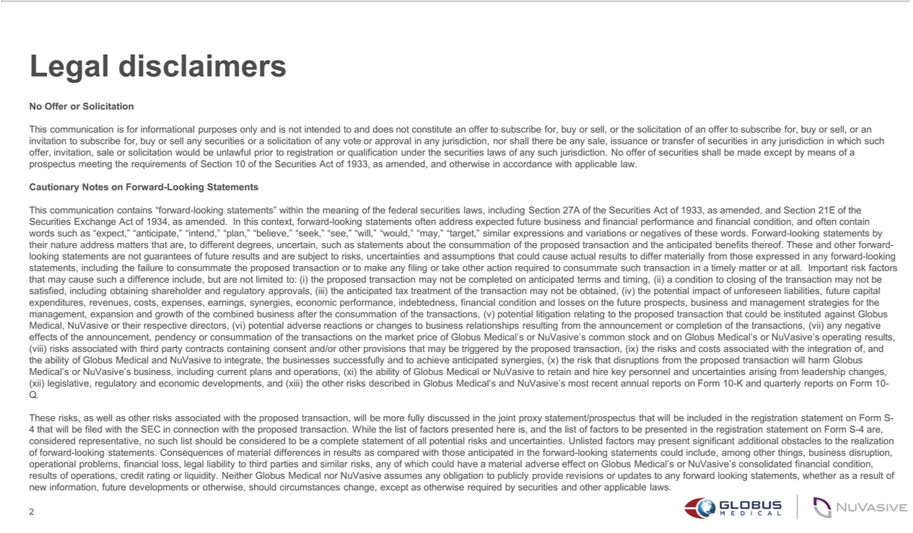

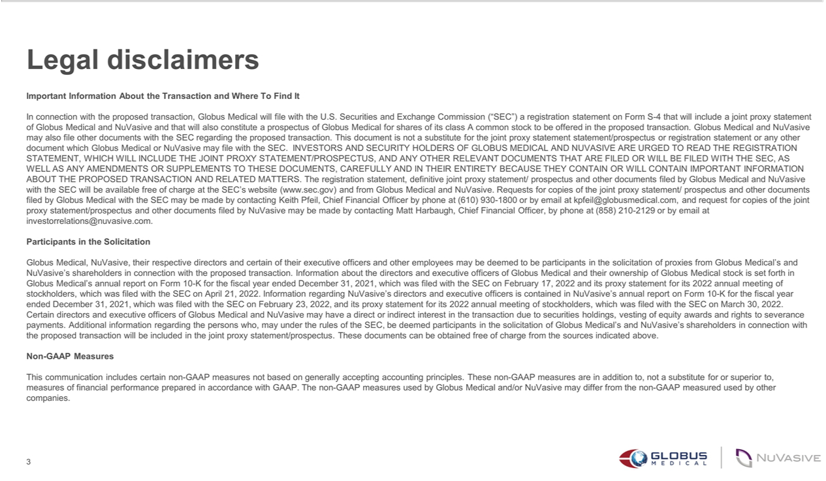



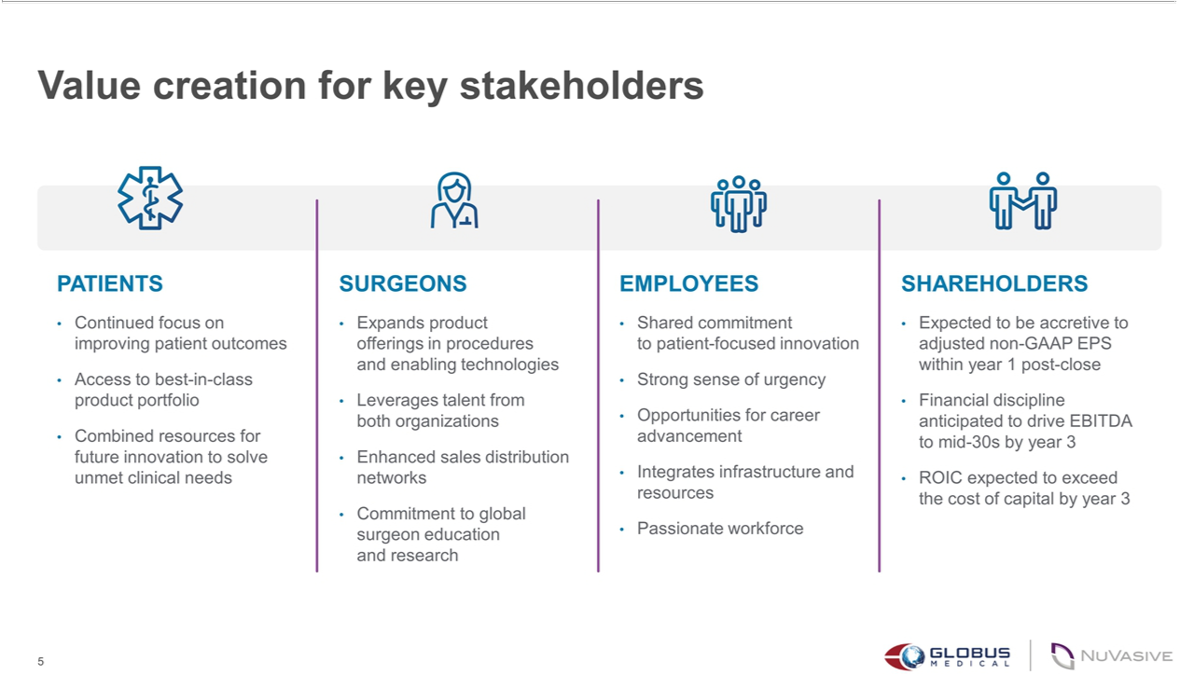

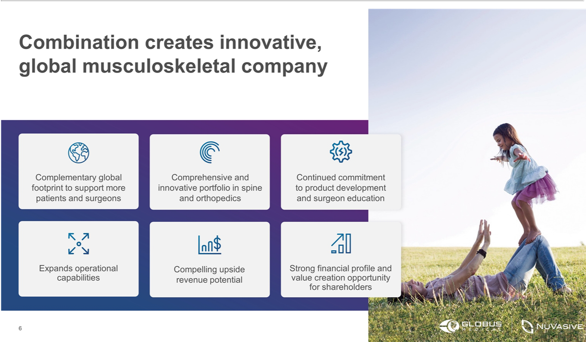

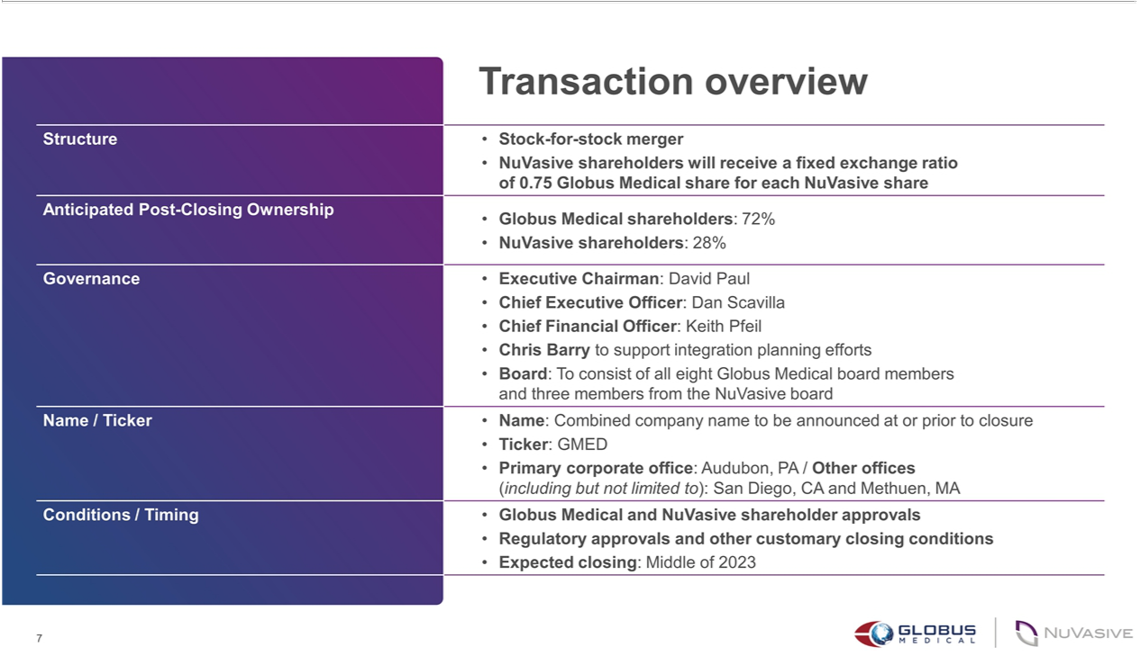

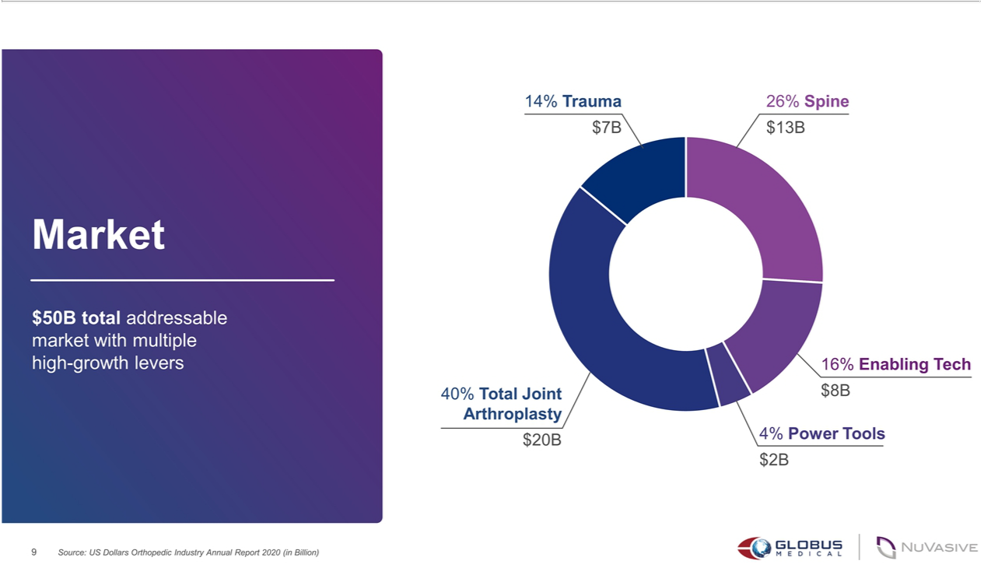

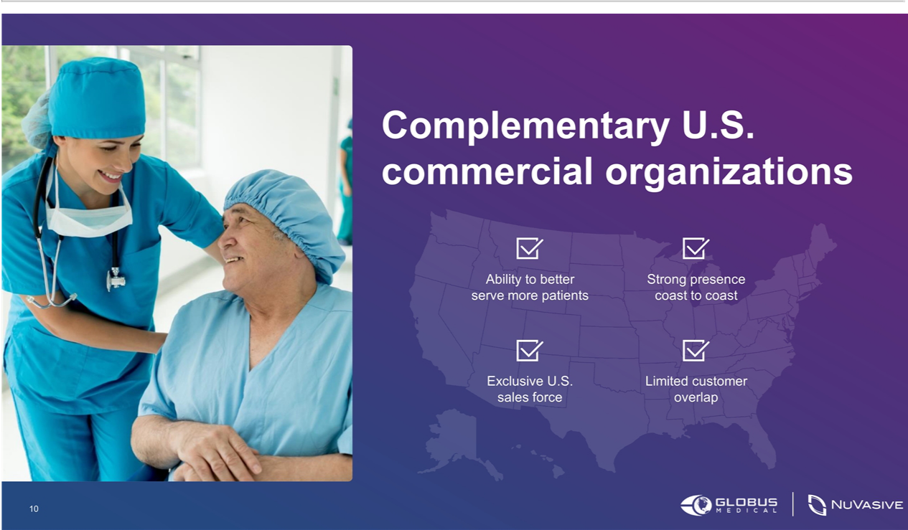

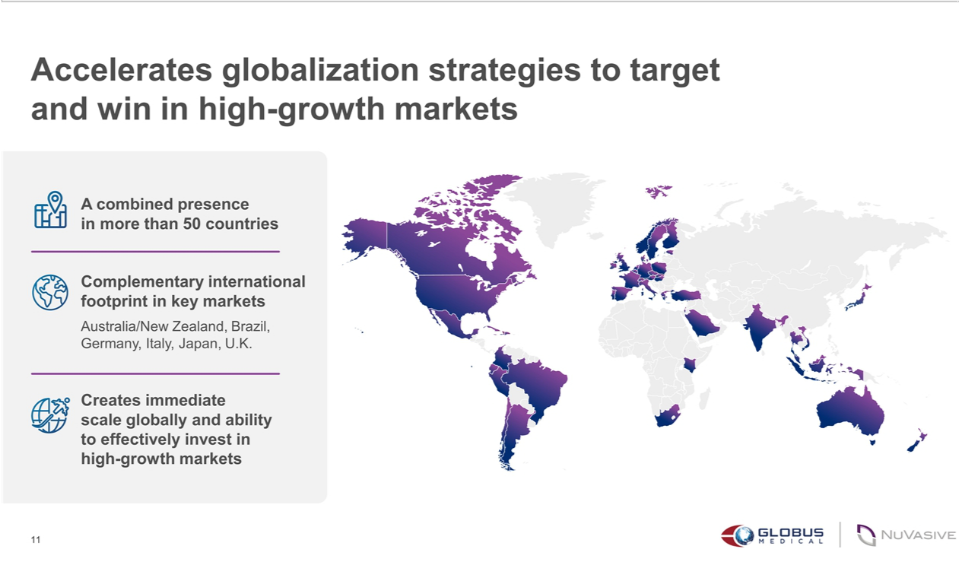

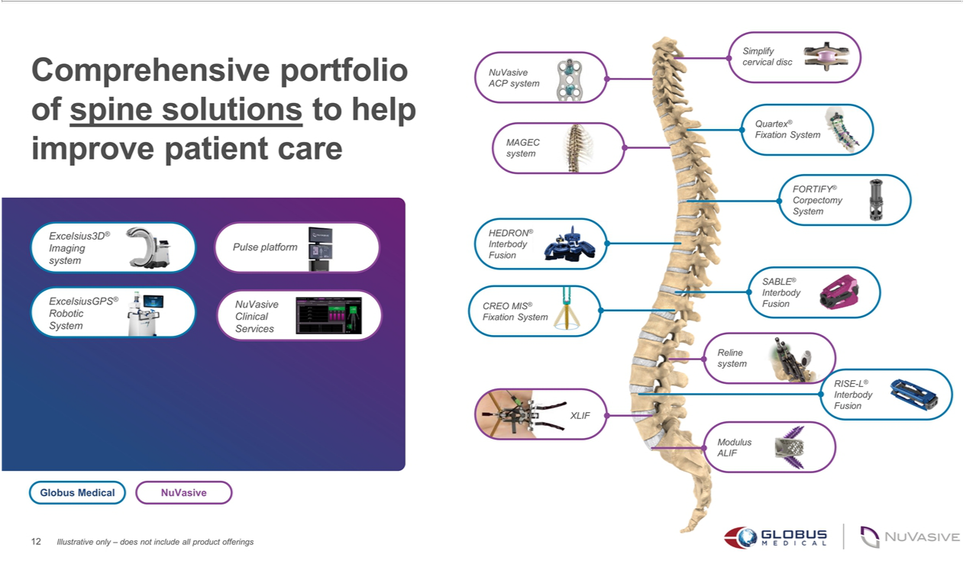

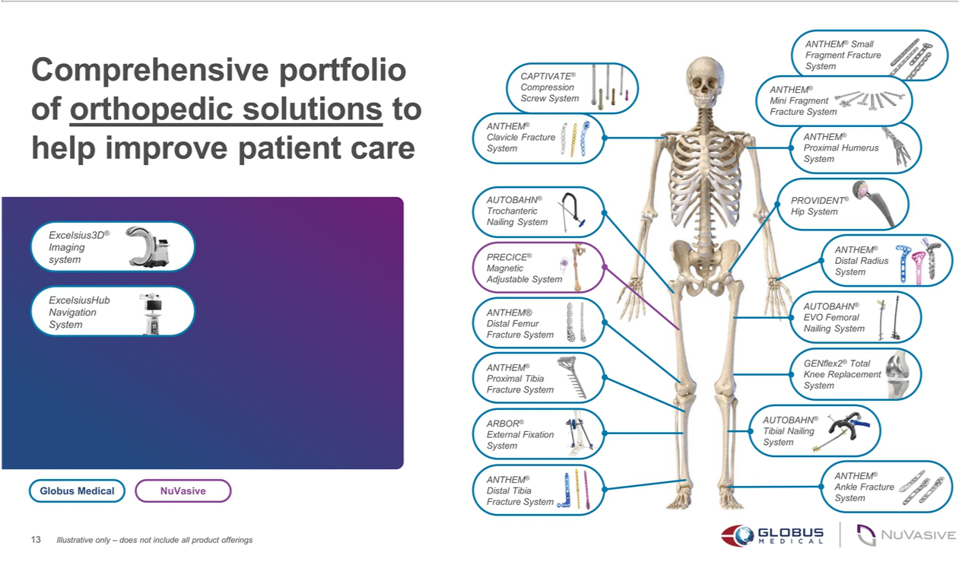

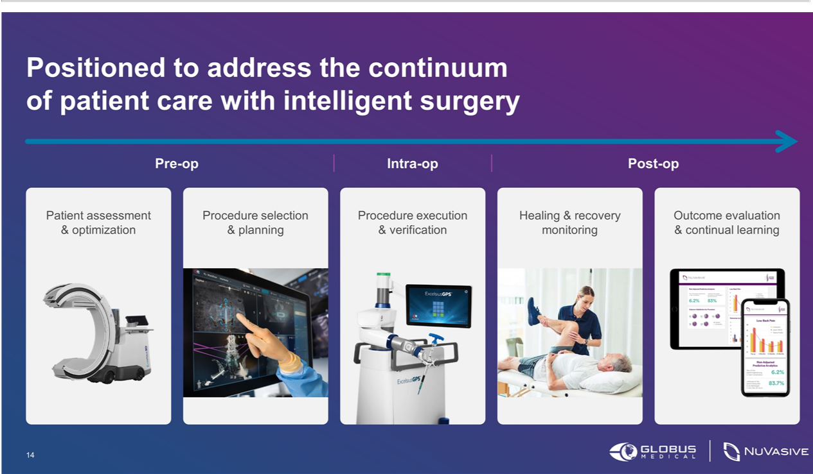

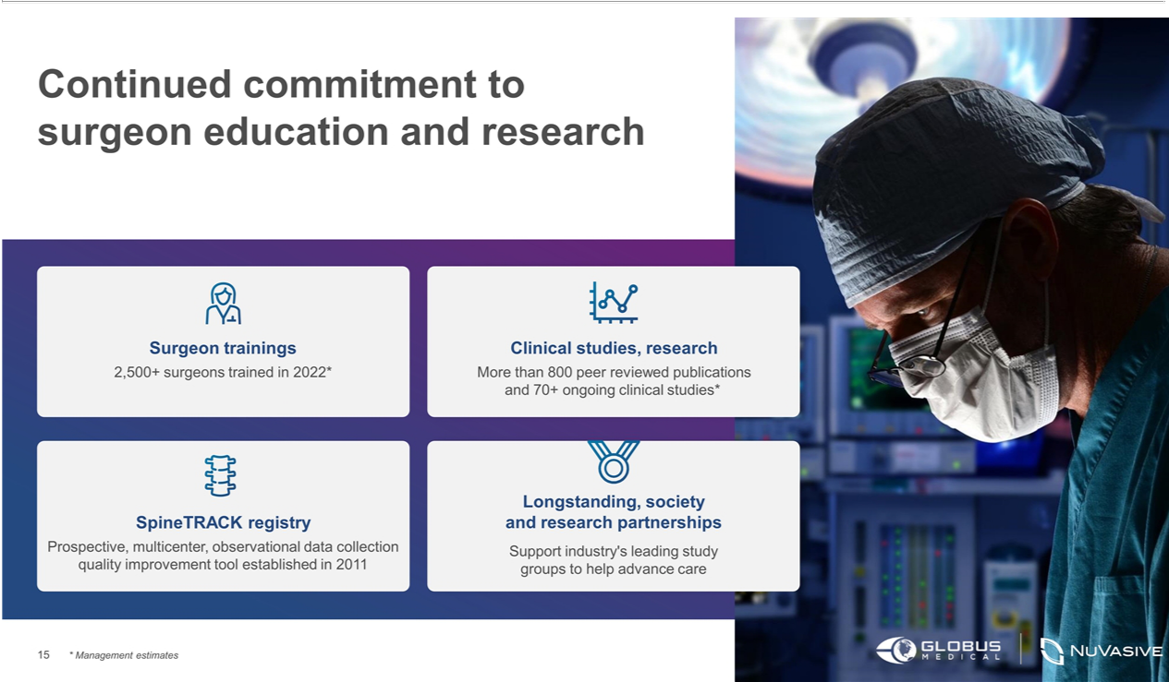

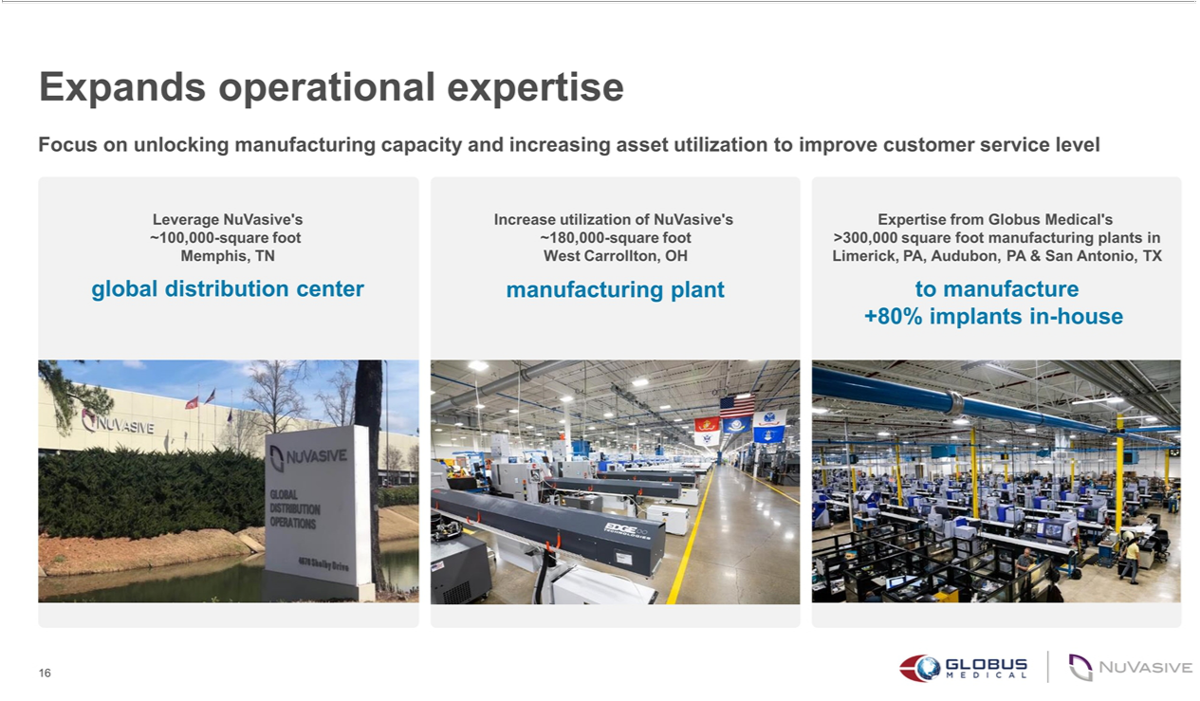



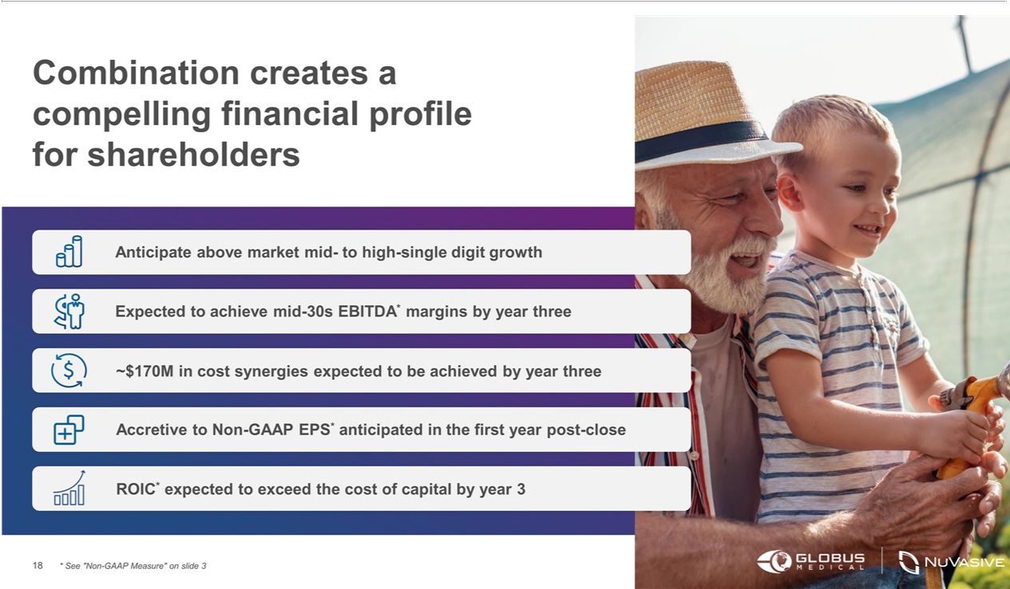

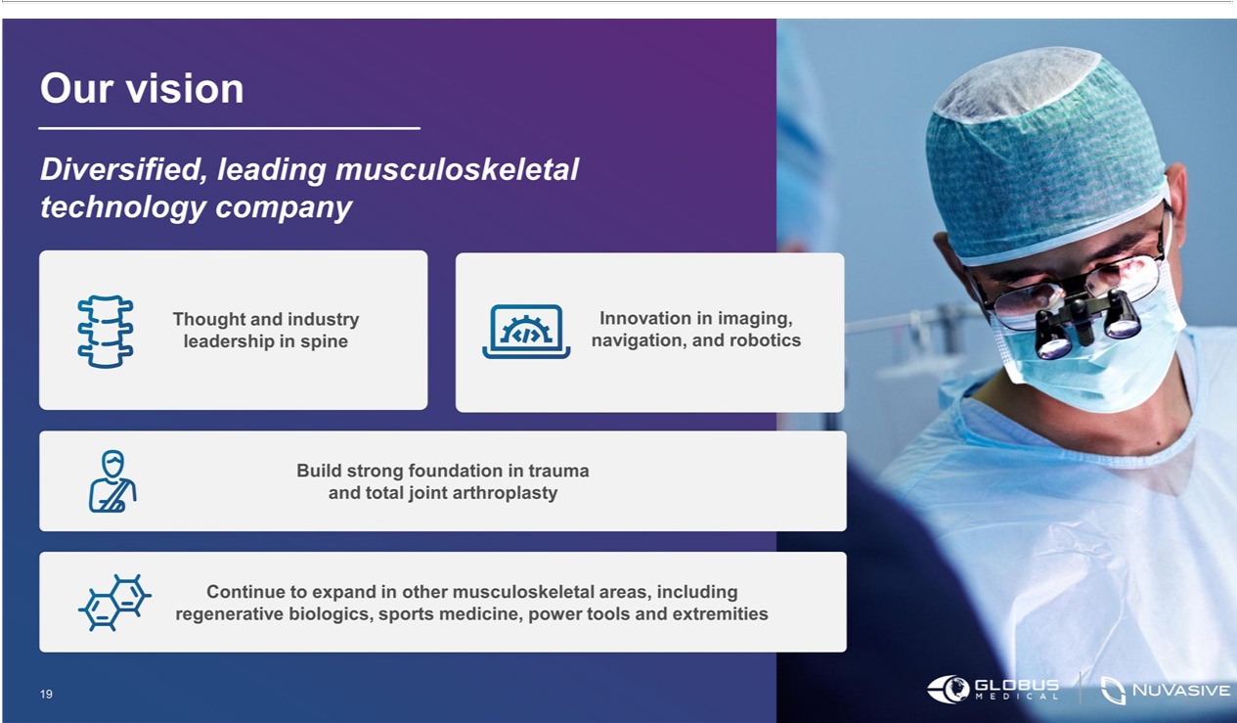

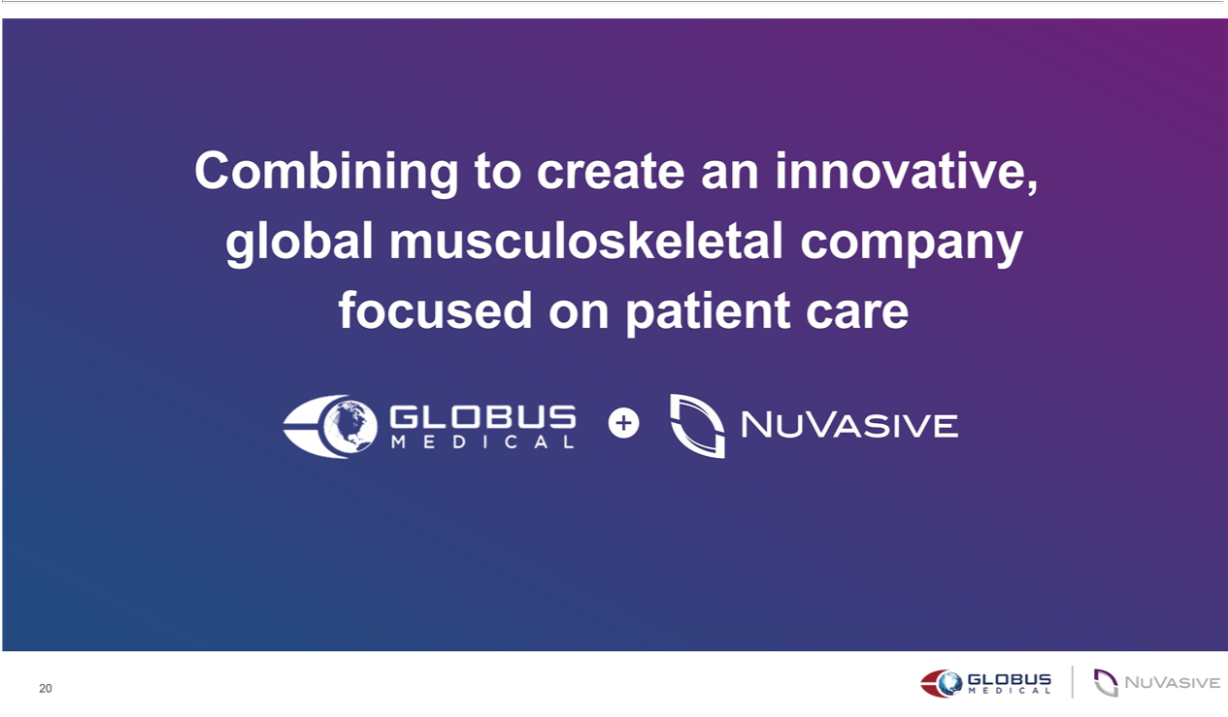

Exhibit 99.2



Globus Medical and NuVasive to Combine in All-Stock Transaction to Create Innovative Global Musculoskeletal Company Focused on Patient Care

Capitalizes on complementary global commercial organizations and accelerates Globus Medical’s and NuVasive’s globalization strategies to increase

customer reach and deepen surgeon relationships

Brings together innovative technologies to create comprehensive procedural solutions offering to better support surgeons, healthcare providers and

patients

Leverages shared commitment to innovation to further both companies’ efforts to address the full continuum of care and help solve unmet clinical needs

Expands operational excellence capabilities to further serve and enable the combined commercial organizations to better support customers

Strong financial profile and value creation opportunity

Companies to host joint conference call today at 8 a.m. ET

Audubon, PA and San Diego, CA – February 9, 2023 – Globus Medical (NYSE: GMED), a leading musculoskeletal solutions company, and NUVASIVE (NASDAQ: NUVA), the leader in spine technology innovation, today announced they have entered into a definitive agreement to combine in an all-stock transaction. The transaction brings together two well-regarded technology companies in the musculoskeletal industry, which have a shared vision focused on innovation in a relentless pursuit of unmet clinical needs to improve patient care.

Under the terms of the agreement, which was unanimously approved by the boards of directors of both companies, NuVasive shareholders will receive 0.75 of a share of Globus Medical Class A common stock for each share of NuVasive common stock owned at the closing of the transaction. Based on this exchange ratio, the implied share price for NuVasive would be $57.72, an equity value of $3.1 billion, based on Globus Medical’s closing share price on February 8. Following the close of the transaction, NuVasive shareholders will own approximately 28% of the combined company, and Globus Medical shareholders will own approximately 72%, on a fully diluted basis.

“This transaction reflects our mission to become the leading musculoskeletal technology company in the world by developing products that promote healing in patients with musculoskeletal disorders,” said Dan Scavilla, president and chief executive officer of Globus Medical. “With NuVasive, we can help support more patients through leading innovation and expanding our commercial reach to provide superior service to our surgeon and hospital partners. We look forward to combining the NuVasive and Globus Medical teams to capitalize on the many opportunities to improve patient care and create sustainable shareholder value.”

Page 1 of 7

“Our combination with Globus Medical is transformative, joining two companies with highly complementary capabilities, geographic footprints and customer bases,” said Chris Barry, chief executive officer of NuVasive. “Together, we will be able to offer an exceptional portfolio of clinically proven solutions, supported by strong commercial and surgeon education teams. The new company will be well-positioned to deliver value creation for shareholders, further support our surgeon partners—and most importantly, change the lives of more patients.”

Strategic and Financial Benefits

- Complementary global scale and expanded commercial reach. The transaction accelerates each company’s globalization strategy to target the $50 billion musculoskeletal market, which includes spine, orthopedics, enabling technology, power tools, biologics and more. Together, Globus Medical and NuVasive will have a presence in more than 50 countries with more than 5,000 employees. The new organization’s larger commercial sales organization will enable it to further penetrate existing and future markets, reaching more surgeons and patients around the world.

- Comprehensive and innovative portfolio in spine and orthopedics. The transaction pairs Globus Medical’s and NuVasive’s complementary spine and orthopedic solutions and enabling technologies to create one of the most comprehensive, innovative offerings in the industry.

- Continued commitment to product development and surgeon education. Globus Medical and NuVasive both have strong records of developing technology that solves unmet clinical needs for the treatment of musculoskeletal disorders. Globus Medical will continue to prioritize collaboration with healthcare professionals to develop these ground-breaking products and solutions to treat the full continuum of care from planning to execution to postoperative data.

- Expands operational capabilities. The company will leverage operational excellence capabilities to further unlock manufacturing capacity and asset utilization to support the commercial organization. Globus Medical and NuVasive will benefit from their respective operational advantages— including but not limited to Globus Medical’s strong, in-house manufacturing capacity and NuVasive’s global distribution networks, including NuVasive’s Memphis-based global distribution center.

- Compelling upside revenue potential. The Globus Medical and NuVasive product, customer, and geographic footprints are highly complementary. As a result, through this transaction, the combined company expects to serve more surgeon customers with more solutions in more geographies around the world, creating compelling growth opportunities over the long-term.

- Strong financial profile and value creation opportunity. The combined companies have strong track records of delivering above-market net sales growth, through their innovation and commercial channels. The company will leverage Globus Medical’s financial rigor and discipline as it aims to deliver a mid-30-percent EBITDA profile over the next three years, which includes approximately $170 million in identified cost synergies.

Page 2 of 7

Leadership

Upon closing of the transaction, the combined company will have an eleven-member board composed of all eight directors from Globus Medical’s board and three directors from NuVasive’s board.

David Paul, Chairman of the Globus Medical board of directors, will serve as Chairman of the combined company’s board of directors, Dan Scavilla will serve as chief executive officer and as a member of the board, Keith Pfeil, chief financial officer of Globus Medical, will serve as chief financial officer of the combined company, and Chris Barry, chief executive officer of NuVasive, will support integration planning of the combined company.

Globus Medical’s and NuVasive’s executive leadership teams will be actively involved in integration planning. Integration efforts will be focused on ensuring continued sales and innovation execution, retaining critical talent, and delivering on growth and cost synergies.

Approvals and Time to Close

The transaction is expected to close in the middle of 2023, subject to the approval of both companies’ shareholders, regulatory approval, and other customary closing conditions.

Financial Outlook

For full year 2022:

- Globus Medical announces preliminary 2022 net sales growth of 6.8% as reported, 8.2% constant currency, as compared to net sales of $958.1 million for the full year 2021; and

- NuVasive announces preliminary 2022 net sales growth of 5.5% as reported, 8.5% constant currency, as compared to net sales of $1,139.0 million for the full year 2021.

For full year 2023:

- Globus Medical expects 2023 net sales growth of 7%-8% constant currency, as compared to full year 2022; and

- NuVasive expects 2023 net sales growth of 6%-8% constant currency, as compared to full year 2022.

Globus Medical will report full financial results for 2022 and provide its financial outlook for 2023 during its earnings announcement planned for February 21. NuVasive will report full financial results for 2022 and provide its financial outlook for 2023 during its earnings announcement planned for February 22.

* Net sales on a constant currency basis excludes impacts of year-over-year foreign currency fluctuations.

Advisors

Goldman Sachs & Co. LLC is serving as financial advisor to Globus Medical, and Goodwin Proctor LLP is serving as legal counsel. BofA Securities, Inc. is serving as financial advisor to NuVasive, and Wachtell, Lipton, Rosen & Katz is serving as legal counsel.

Page 3 of 7

Conference Call and Webcast

Globus Medical and NuVasive will host a joint conference call today at 8 a.m. ET to discuss the transaction.

Participants may access the conference call live via webcast and associated presentation materials on the investor relations section of Globus Medical and NuVasive’s websites or via this link.

To participate via telephone, please register via this link. Upon registration, all telephone participants will receive a confirmation email detailing how to join the conference call, including the dial-in number along with a unique passcode and registrant ID that can be used to access the call.

About Globus Medical

Globus Medical is a leading musculoskeletal solutions company based in Audubon, PA. The company was founded in 2003 by an experienced team of professionals with a shared vision to create products that enable surgeons to promote healing in patients with musculoskeletal disorders. Additional information can be accessed at www.globusmedical.com.

About NuVasive

NuVasive is a leader in spine technology innovation, with a mission to transform surgery, advance care, and change lives. The company’s less-invasive, procedurally integrated surgical solutions are designed to deliver reproducible and clinically proven outcomes. With more than $1 billion in net sales, NuVasive operates in more than 50 countries serving surgeons, hospitals, and patients. For more information, please visit www.nuvasive.com.

No Offer or Solicitation

This communication is for informational purposes only and is not intended to and does not constitute an offer to subscribe for, buy or sell, or the solicitation of an offer to subscribe for, buy or sell, or a solicitation of any vote or approval in any jurisdiction, nor shall there be any sale, issuance or transfer of securities in any jurisdiction in which such offer, sale or solicitation would be unlawful prior to registration or qualification under the securities laws of any such jurisdiction. No offer of securities shall be made except by means of a prospectus meeting the requirements of Section 10 of the Securities Act of 1933, as amended, and otherwise in accordance with applicable law.

Non-GAAP Financial Measures

This communication includes certain non-GAAP measures not based on generally accepting accounting principles. These non-GAAP measures are in addition to, not a substitute for or superior to, measures of financial performance prepared in accordance with GAAP. The non-GAAP measures used by Globus Medical and/or NuVasive may differ from the non-GAAP measured used by other companies.

Cautionary Notes on Forward-Looking Statements

This communication contains “forward-looking statements” within the meaning of the federal securities laws, including Section 27A of the Securities Act of 1933, as amended, and Section 21E of the Securities Exchange Act of 1934, as amended. In this context, forward-looking statements often address expected future business and financial performance and financial condition, and often contain

Page 4 of 7

words such as “expect,” “anticipate,” “intend,” “plan,” “believe,” “seek,” “see,” “will,” “would,” “may,” “target,” and similar expressions and variations or negatives of these words. Forward-looking statements by their nature address matters that are, to different degrees, uncertain, such as statements about the consummation of the proposed transaction and the anticipated benefits thereof. Forward-looking statements also include statements regarding the companies’ expected net sales results for 2022 and financial outlook for 2023. These and other forward-looking statements are not guarantees of future results and are subject to risks, uncertainties and assumptions that could cause actual results to differ materially from those expressed in any forward-looking statements, including the failure to consummate the proposed transaction or to make any filing or take other action required to consummate such transaction in a timely matter or at all. Important risk factors that may cause such a difference include, but are not limited to: (i) the proposed transaction may not be completed on anticipated terms and timing, (ii) a condition to closing of the transaction may not be satisfied, including obtaining shareholder and regulatory approval, (iii) the anticipated tax treatment of the transaction may not be obtained, (iv) the potential impact of unforeseen liabilities, future capital expenditures, revenues, costs, expenses, earnings, synergies, economic performance, indebtedness, financial condition and losses on the future prospects, business and management strategies for the management, expansion and growth of the combined business after the consummation of the transactions, (v) potential litigation relating to the proposed transaction that could be instituted against Globus Medical, NuVasive or their respective directors, (vi) potential adverse reactions or changes to business relationships resulting from the announcement or completion of the transactions, (vii) any negative effects of the announcement, pendency or consummation of the transactions on the market price of Globus Medical’s or NuVasive’s common stock and on Globus Medical’s or NuVasive’s businesses or operating results, (viii) risks associated with third party contracts containing consent and/or other provisions that may be triggered by the proposed transaction, (ix) the risks and costs associated with the integration of, and the ability of Globus Medical and NuVasive to integrate, their businesses successfully and to achieve anticipated synergies, (x) the risk that disruptions from the proposed transaction will harm Globus Medical’s or NuVasive’s business, including current plans and operations, (xi) the ability of Globus Medical or NuVasive to retain and hire key personnel and uncertainties arising from leadership changes, (xii) legislative, regulatory and economic developments, and (xiii) the other risks described in Globus Medical’s and NuVasive’s most recent annual reports on Form 10-K and quarterly reports on Form 10-Q.

These risks, as well as other risks associated with the proposed transaction, will be more fully discussed in the joint proxy statement/prospectus that will be included in the registration statement on Form S-4 that will be filed with the SEC in connection with the proposed transaction. While the list of factors presented here is, and the list of factors to be presented in the registration statement on Form S-4 are, considered representative, no such list should be considered to be a complete statement of all potential risks and uncertainties. Unlisted factors may present significant additional obstacles to the realization of forward-looking statements. Consequences of material differences in results as compared with those anticipated in the forward-looking statements could include, among other things, business disruption, operational problems, financial loss, legal liability to third parties and similar risks, any of which could have a material adverse effect on Globus Medical’s or NuVasive’s consolidated financial condition, results of operations, credit rating or liquidity. Neither Globus Medical nor NuVasive assumes any obligation to publicly provide revisions or updates to any forward looking statements, whether as a result of new information, future developments or otherwise, should circumstances change, except as otherwise required by securities and other applicable laws.

Page 5 of 7

Important Information About the Transaction and Where To Find It

In connection with the proposed transaction, Globus Medical will file with the U.S. Securities and Exchange Commission (“SEC”) a registration statement on Form S-4 that will include a joint proxy statement of Globus Medical and NuVasive and that will also constitute a prospectus of Globus Medical for shares of its class A common stock to be offered in the proposed transaction. Globus Medical and NuVasive may also file other documents with the SEC regarding the proposed transaction. This document is not a substitute for the joint proxy statement statement/prospectus or registration statement or any other document which Globus Medical or NuVasive may file with the SEC. INVESTORS AND SECURITY HOLDERS OF GLOBUS MEDICAL AND NUVASIVE ARE URGED TO READ THE REGISTRATION STATEMENT, WHICH WILL INCLUDE THE JOINT PROXY STATEMENT/PROSPECTUS, AND ANY OTHER RELEVANT DOCUMENTS THAT ARE FILED OR WILL BE FILED WITH THE SEC, AS WELL AS ANY AMENDMENTS OR SUPPLEMENTS TO THESE DOCUMENTS, CAREFULLY AND IN THEIR ENTIRETY BECAUSE THEY CONTAIN OR WILL CONTAIN IMPORTANT INFORMATION ABOUT THE PROPOSED TRANSACTION AND RELATED MATTERS. The registration statement, definitive joint proxy statement/ prospectus and other documents filed by Globus Medical and NuVasive with the SEC will be available free of charge at the SEC’s website (www.sec.gov) and from Globus Medical and NuVasive. Requests for copies of the joint proxy statement/ prospectus and other documents filed by Globus Medical with the SEC may be made by contacting Keith Pfeil, Chief Financial Officer by phone at

- 930-1800 or by email at kpfeil@globusmedical.com, and request for copies of the joint proxy statement/prospectus and other documents filed by NuVasive may be made by contacting Matt Harbaugh, Chief Financial Officer, by phone at (858) 210-2129 or by email at investorrelations@nuvasive.com.

Participants in the Solicitation

Globus Medical, NuVasive, their respective directors and certain of their executive officers and other employees may be deemed to be participants in the solicitation of proxies from Globus Medical’s and NuVasive’s shareholders in connection with the proposed transaction. Information about the directors and executive officers of Globus Medical and their ownership of Globus Medical stock is set forth in Globus Medical’s annual report on Form 10-K for the fiscal year ended December 31, 2021, which was filed with the SEC on February 17, 2022 and its proxy statement for its 2022 annual meeting of stockholders, which was filed with the SEC on April 21, 2022. Information regarding NuVasive’s directors and executive officers is contained in NuVasive’s annual report on Form 10-K for the fiscal year ended December 31, 2021, which was filed with the SEC on February 23, 2022, and its proxy statement for its 2022 annual meeting of stockholders, which was filed with the SEC on March 30, 2022. Certain directors and executive officers of Globus Medical and NuVasive may have a direct or indirect interest in the transaction due to securities holdings, vesting of equity awards and rights to severance payments. Additional information regarding the persons who may, under the rules of the SEC, be deemed participants in the solicitation of Globus Medical’s and NuVasive’s shareholders in connection with the proposed transaction will be included in the joint proxy statement/prospectus. These documents can be obtained free of charge from the sources indicated above.

Page 6 of 7

Contacts

Globus Medical

Investors and Media

Brian Kearns

610-930-1800

investors@globusmedical.com

NuVasive

Investors

Juliet C. Cunningham

858-210-2129

investorrelations@nuvasive.com

Media

Melanie Ordoñez

858-722-3899

media@nuvasive.com

Page 7 of 7

